Federal Premium Terminal Ascent Velocity Spectrum

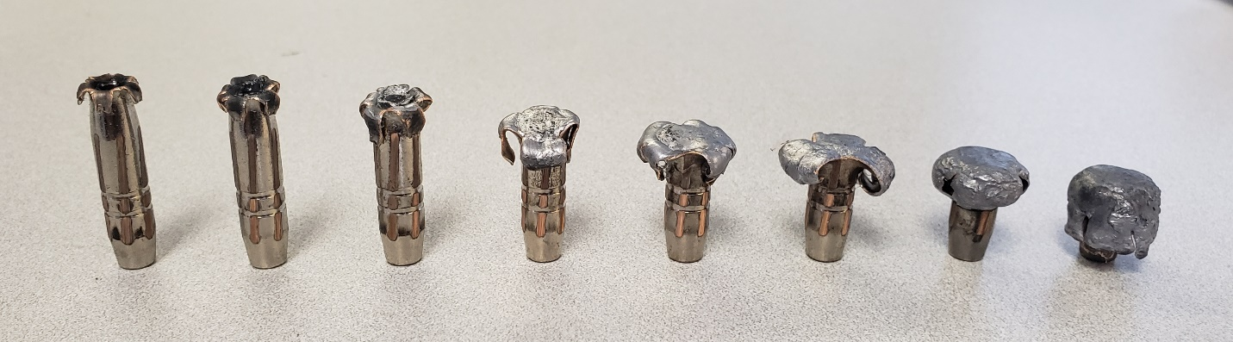

DATA TABLE
Upset: 1 2 3 4 5 6 7 8
Velocity: 1350 1500 1700 1900 2100 2300 2800 2900
Distance (yds): 1350 1200 1000 800 650 500 100 10
Diameter (in): 0.400 0.400 0.475 0.575 0.675 0.750 0.650 0.625
Weight Retention: 99% 99% 99% 98% 98% 95% 94% 87%

Notes:
Distances shown downloads from a ballistic calculator.
Velocity numbers shown are values used when hand-loading cartridges.
All data and photos are from Federal engineers testing at the Anoka, Minnesota factory.

